Divyansh Mishra

23BCE5071

**Web Programming**

**Assignment – 9**

Q1

**CODE:**

<!DOCTYPE html>

<html>

<head>

    <title>New York Temperature Analysis</title>

    <style>

        table {

            width: 50%;

            border-collapse: collapse;

            margin: 20px 0;

        }

        table, th, td {

            border: 1px solid black;

        }

        th, td {

            padding: 8px;

            text-align: center;

        }

    </style>

</head>

<body>

    <h1>New York Temperature Analysis</h1>

    <table id="temperatureTable">

        <tr>

            <th>Day</th>

            <th>Temperature (°F)</th>

            <th>Category</th>

        </tr>

    </table>

    <p id="summary"></p>

    <script>

        const temperatures = [55,62,68,74,59,45,41,58,60,67,65,78,82,88,91,92,90,93,87,80,78,79,72,68,61,59,55,65];

        let hotDays = 0;

        let pleasantDays = 0;

        let coldDays = 0;

        const table = document.getElementById("temperatureTable");

        temperatures.forEach((temp, index) => {

            let category;

            if (temp >= 85) {

                category = "HOT";

                hotDays++;

            } else if (temp >= 60 && temp <= 84) {

                category = "Pleasant";

                pleasantDays++;

            } else {

                category = "COLD";

                coldDays++;

            }

            const row = table.insertRow();

            row.innerHTML = `<td>Day ${index + 1}</td><td>${temp}</td><td>${category}</td>`;

        });

        document.getElementById("summary").innerHTML =

            `Number of HOT days: ${hotDays} <br>

             Number of Pleasant days: ${pleasantDays} <br>

             Number of COLD days: ${coldDays}`;

    </script>

</body>

</html>

**Output:**

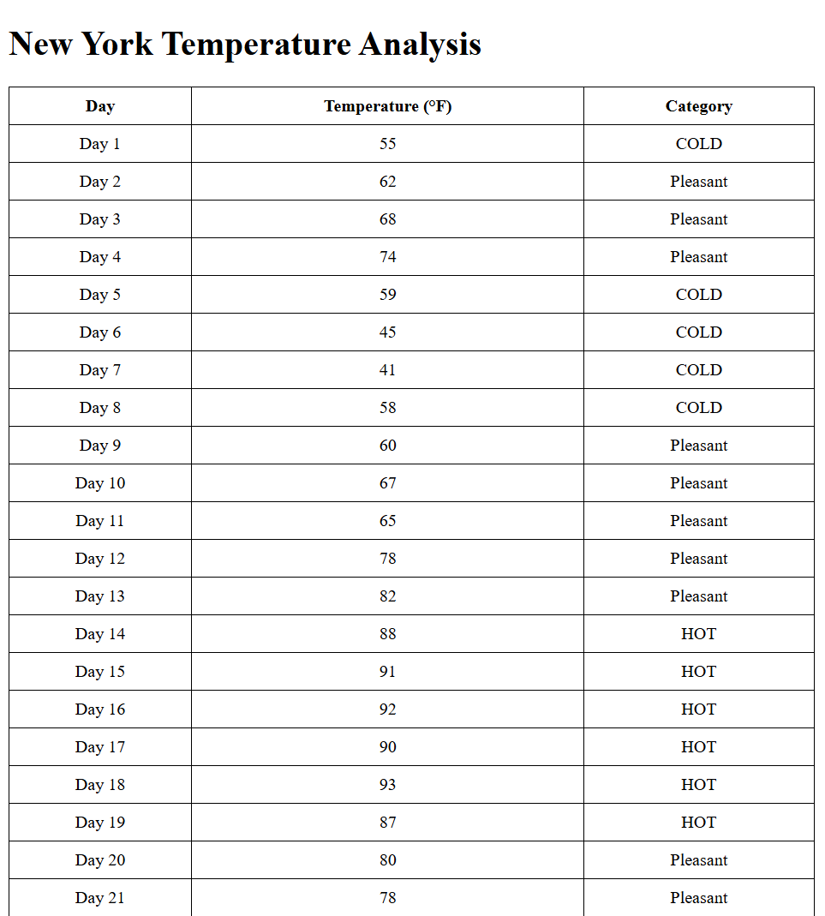 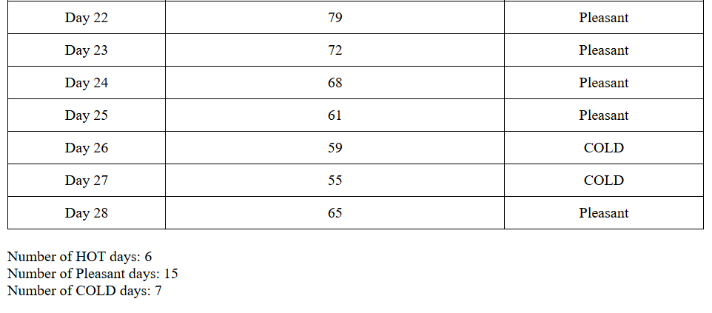

Q2

**CODE:**

<!DOCTYPE html>

<html>

<head>

    <title>Airline Reservation System</title>

</head>

<body>

    <h1>Airline Reservation System</h1>

    <label for="name">Enter your name:</label>

    <input type="text" id="name" required>

    <br><br>

    <label>Select Class:</label>

    <button onclick="bookSeat(1)">First Class (1-5)</button>

    <button onclick="bookSeat(2)">Economy (6-10)</button>

    <br><br>

    <p id="message"></p>

    <h2>Seating Chart:</h2>

    <ul id="seatingChart"></ul>

    <script>

        const seats = Array(10).fill(0);

        function displaySeatingChart() {

            const chart = document.getElementById("seatingChart");

            chart.innerHTML = '';

            seats.forEach((status, index) => {

                const seatStatus = status === 0 ? 'Empty' : 'Booked';

                chart.innerHTML += `<li>Seat ${index + 1}: ${seatStatus}</li>`;

            });

        }

        function bookSeat(classType) {

            const name = document.getElementById("name").value.trim();

            if (name === '') {

                alert("Please enter your name.");

                return;

            }

            let start, end;

            if (classType === 1) {

                start = 0;

                end = 5;

            } else if (classType === 2) {

                start = 5;

                end = 10;

            }

            for (let i = start; i < end; i++) {

                if (seats[i] === 0) {

                    seats[i] = 1;

                    document.getElementById("message").innerHTML =

                        `Boarding Pass:<br> Name: ${name} <br> Seat Number: ${i + 1} <br> Class: ${classType === 1 ? 'First Class' : 'Economy'}`;

                    displaySeatingChart();

                    return;

                }

            }

            if (classType === 1) {

                if (confirm("First Class is full. Would you like to be placed in Economy?")) {

                    bookSeat(2);

                } else {

                    alert("Sorry! No more first class seats available.");

                }

            } else if (classType === 2) {

                if (confirm("Economy is full. Would you like to be placed in First Class?")) {

                    bookSeat(1);

                } else {

                    alert("Sorry! No more economy seats available.");

                }

            }

        }

        displaySeatingChart();

    </script>

</body>

</html>

**OUTPUT:**

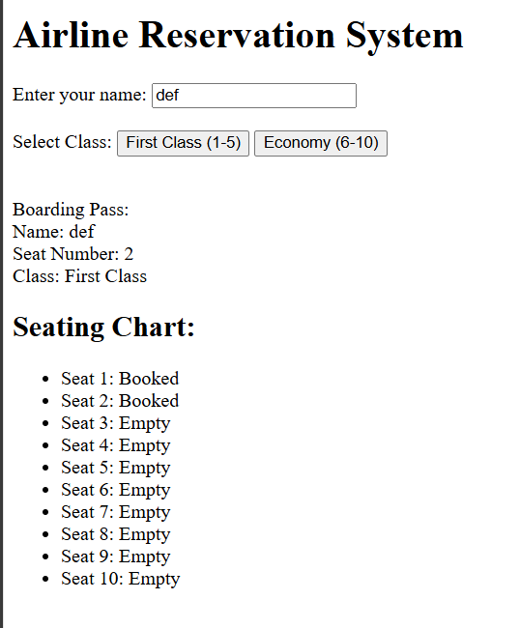

 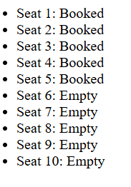

Q3

**CODE:**

<!DOCTYPE html>

<html>

<head>

    <title>BMI Calculator</title>

    <style>

        body {

            font-family: Arial, sans-serif;

            text-align: center;

            margin-top: 50px;

        }

        #bmiCalculator {

            border: 1px solid #000;

            display: inline-block;

            padding: 20px;

            box-shadow: 5px 5px 15px rgba(0,0,0,0.2);

        }

        input {

            margin: 5px;

        }

    </style>

</head>

<body>

    <div id="bmiCalculator">

        <h2>BMI Calculator</h2>

        <label>Select Gender: </label>

        <select id="gender">

            <option value="male">Male</option>

            <option value="female">Female</option>

        </select>

        <br><br>

        <label>Enter Your Weight: (in pounds)</label>

        <br>

        <input type="number" id="weight" placeholder="Weight" required>

        <br><br>

        <label>Enter Your Height:</label>

        <br>

        <input type="number" id="feet" placeholder="Feet" required>

        <input type="number" id="inches" placeholder="Inches" required>

        <br><br>

        <button onclick="calculateBMI()">Calculate</button>

        <h3>YOUR BMI: <span id="bmiResult">--</span></h3>

    </div>

    <script>

        function calculateBMI() {

            const weight = parseFloat(document.getElementById("weight").value);

            const feet = parseFloat(document.getElementById("feet").value);

            const inches = parseFloat(document.getElementById("inches").value);

            const gender = document.getElementById("gender").value;

            if (isNaN(weight) || isNaN(feet) || isNaN(inches) || weight <= 0 || feet < 0 || inches < 0) {

                alert("Please enter valid inputs.");

                return;

            }

            const totalHeightInInches = (feet * 12) + inches;

            const bmi = (703 * weight) / (totalHeightInInches * totalHeightInInches);

            const bmiRounded = bmi.toFixed(2);

            document.getElementById("bmiResult").innerText = bmiRounded;

            let status = "";

            if (gender === "male") {

                if (bmi < 17.50) status = "Anorexia";

                else if (bmi >= 17.501 && bmi <= 20.70) status = "Underweight";

                else if (bmi >= 20.71 && bmi <= 26.40) status = "Ideal Range";

                else if (bmi >= 26.41 && bmi <= 27.80) status = "Marginally Overweight";

                else if (bmi >= 27.81 && bmi <= 31.10) status = "Overweight";

                else if (bmi > 31.10) status = "Very Overweight or Obese";

            } else if (gender === "female") {

                if (bmi < 17.50) status = "Anorexia";

                else if (bmi >= 17.51 && bmi <= 19.10) status = "Underweight";

                else if (bmi >= 19.11 && bmi <= 25.80) status = "Ideal Range";

                else if (bmi >= 25.81 && bmi <= 27.30) status = "Marginally Overweight";

                else if (bmi >= 27.31 && bmi <= 32.30) status = "Overweight";

                else if (bmi > 32.30) status = "Very Overweight or Obese";

            }

            alert(`Your BMI is ${bmiRounded}. Status: ${status}`);

        }

    </script>

</body>

</html>

**OUTPUT:**

